A Brief Background of Ancient Greek Tragedy

- The tragic genre is perhaps the oldest genre in literature, dating back to the ancient Greeks. Interestingly, tragedy evolved out of ancient Greek celebrations of Dionysus, the god of wine and fertility. A great deal of ink has been spilled over why the god of life would be celebrated with tragedy. Aristotle claimed that tragedy elicits a certain kind of “pleasure” from the audience, an interesting issue we will have to discuss.

- Tragedy held a central role in the political, social and religious life of the ancient Greeks. Tragic plays, particularly in the 5th century BC, were held in Olympiad performances annually and were mandatory.
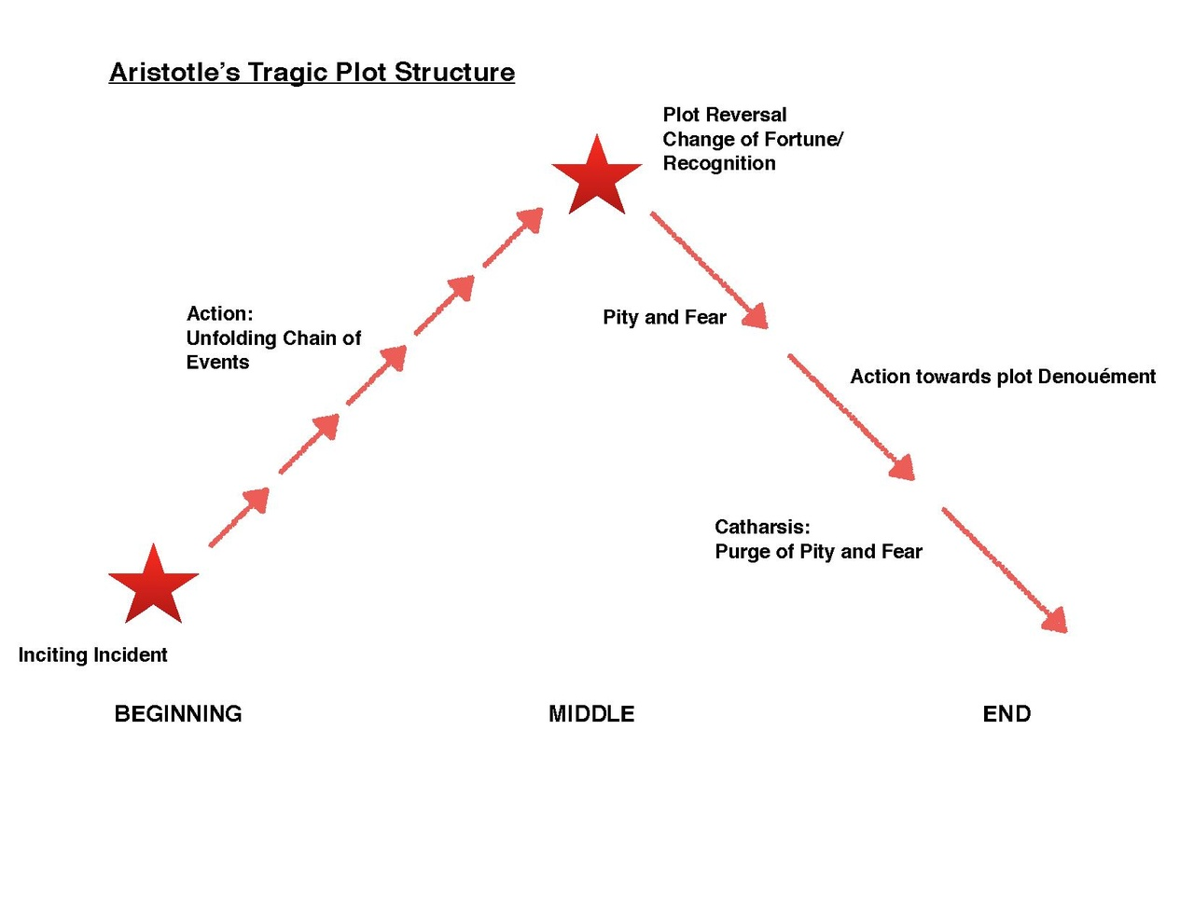

The Conventions of a Tragedy:

- Tragedies follow a simple (and yet specific) plot pattern. The most basic plot of a tragedy involves a protagonist who desires something—object of love, power, wealth, righteousness, justice—and obstacles come in the way of his path to reach its fulfillment. After undergoing a series of challenges, tests and mishaps, the protagonist does not overcome the obstacles, which ultimately destroy him.

- Any narrative might be labeled either comic or tragic, depending upon the ending. If it ends in division, divorce, death, alienation or dissatisfaction, the narrative is tragic. If it ends with union, marriage, life, community, satisfaction, the narrative is comic.

- Tragedies have at least one protagonist who is the tragic hero. The tragic hero is a figure who is either larger than life or holds some position in the world that places him near the top of humanity. In most tragedies, the tragic hero is someone we either “like,” (we do not have to love him), or respect, and / or for whom with empathize. The latter is perhaps the most important. We must in some way empathize or sympathize with the tragic hero; if not, we do not feel the pity and terror when he comes to a tragic fall.

- All tragedies involve some sort of tragic fall of the tragic hero: at crises or climaxes in the play, the tragic hero falls from the height of his power or stature in the world, and the fall is usually fast and deep.

- The moment of the tragic fall—when the tragic hero actually falls from his height—can be interpreted in many ways. In many tragedies, particularly ancient Greek plays, the tragic hero experiences a sort of final, complete fall, right after he experiences recognition, a moment in which he comes to clear, sudden awareness of his tragic position in life. For instance, Oedipus comes to his fall when he realizes unequivocally that he had killed his father and slept with his mother.
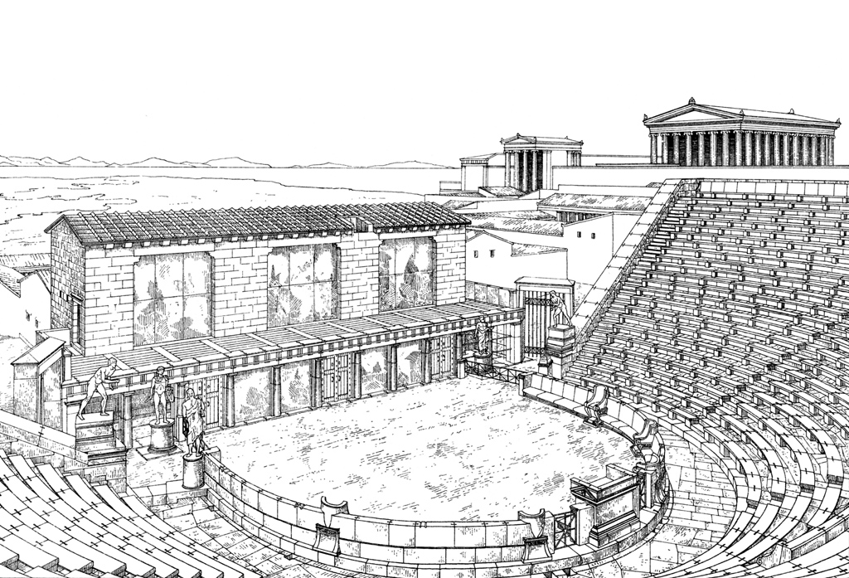
- Most of the time, the tragic hero falls as a result of harmatia, or what has come to be known as a tragic flaw. The notion of a tragic flaw, however, has been rather misunderstood by students over time, who have come to believe that it means the tragic hero has some sort of singular fault—an Achilles heel, so to speak—that is responsible for his downfall. It is not as simple as that. The idea behind a tragic flaw is really wrapped up in a more existential notion of human frailties or weaknesses that we all might share, and become that which prods the tragic hero into disaster.

- But the tragic flaw may also involve some king of tragic circumstance, conditions that are mostly out of the tragic hero’s control. Such circumstance has often been called fate.

- Often there is a great deal of debate between how much of the tragic outcome in a play is a result of fate and how much is the result of the control, the free-will, of the tragic hero and the other characters.

- Tragedy always ends / resolves in some vision of wreckage, waste, alienation, emptiness, division, signified usually by either death and / or exile. In Christian literature, such a vision can often be apocalyptic, depicting some vision or foreshadowing of the end of the world. The apocalypse is often depicted as mayhem, destruction, divorce, death.

- The climax and resolution to a tragedy elicits particular emotions / responses from an audience. Aristotle’s theory of the effects of the tragic ending still persists today. He claimed that tragedy creates a sense of catharsis in the viewer / reader. What exactly catharsis means has been one of the biggest debates amongst literary critics—books upon books have been written on the subject. Generally, it seems to indicate the means that tragedy exacerbates our feelings of pity, terror and despair, which is then followed by a sense of purgation, or relief from those very extreme emotions, leaving us more balanced (whether emotionally, morally or socially is often debated). We come out of tragedy feeling cleansed and perhaps relieved of the extreme emotions that the play incited. Many point to the “good cry” one might experience after a really sad movie as an example of the emotional effects of catharsis.

- Often, as we will see, the ultimate tragic ending will be preceded by peripetia, or what we have come to know as the plot twist. Just as the plot seems to be on the verge of resolving in one way, usually happily or satisfactorily, something happens that twists the plot into an ultimate and unexpectedly tragic ending. The plot twist can terribly exacerbate the tragedy.

